NEEM & ALOVERA SOAP100g₹180.00

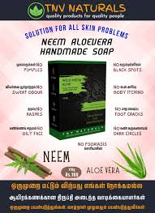

Skin clearance soap
Feel the change in first time usage. Made by cold process method. No Pimples. No Itching. Solution for all skin problems. Anti bacterial, Anti Fungal. Clears pimples, rashes and Moisturize skin. Vitamin C clears dullness and skin infections. Deep Cleansing. Lighten scars and pigmentation caused by acne.

NEEM OIL ₹ 180 100 ML

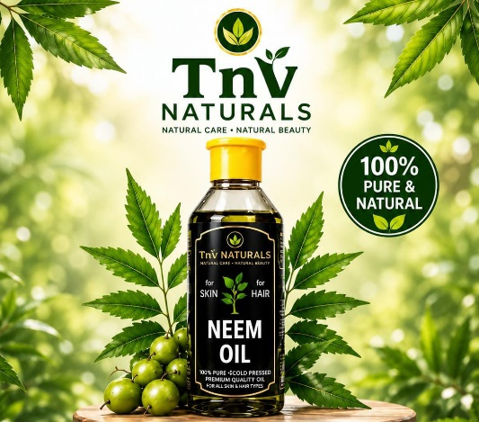
Benefits :
Acne Control - Anti-Inflammatory Balances Sebum Production
Natural Skin Cleanser Skin Nourishment Antioxidant Protection
Directions :
Apply and Massage the scalp gently.
Leave for an hour or more and wash.
For acne control, apply directly to the
affected areas. Leave it overnight
or rinse off after 30 minutes.

WHITE GOLD BUTTER SOAP ₹220.00 110 g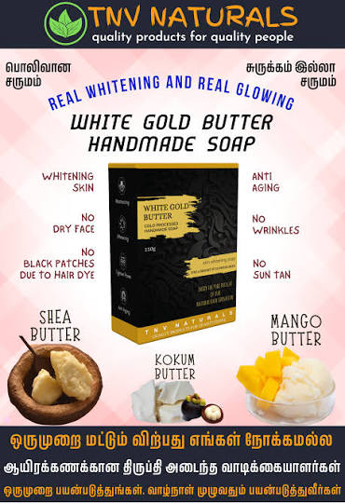
Real Skin Whitening Soap
Feel the change in first time usage. Made by cold process method.
For a whitening and glowing skin. Perfect combination of 3 high quality butters
1. Shea butter
2. Mango butter
3. Kokum butter
Soothes irritated skin - reduces the signs of aging fights acne and fades blemishes. removes dark circles and puffiness. moisturizes and heals dry and flaky skin makes skin clear, soft and whitening.
Why Shea butter?
Linoleic, palmitic, stearic, and oleic fatty acids, ingredients that balance oils on your skin vitamins A, E, and F, antioxidant vitamins that promote circulation and healthy skin cell growth triglycerides, the fatty part of the shea nut that nourishes and conditions your skin cetyl esters, the waxy part of the shea butter that conditions skin and locks in moisture
Why mango butter?
It is an excellent source of triglycerides (a form of glycerin). that Eliminates Itchy And Dry Skin contains antioxidants that fight free radicals in ur skin. when our skin is exposed to sunlight aids in collagen production, that keeps your skin firm and wrinkle-free
It’s also non-comedogenic, so you don’t have to worry about clogged pores or breakouts.
Why kokum butter?
Remarkably light, absorbed quickly and easily, and not greasy to your skin. It softens the skin and restores its elasticity for a youthful glow. antioxidant and anti-inflammatory properties, heals, soothes inflamed and damaged skin high in essential fatty acids like omega-3 and omega-6 help your body sustain healthy skin.

Real Skin Whitening Soap
Feel the change in first time usage. Made by cold process method.
For a whitening and glowing skin. Perfect combination of 3 high quality butters
1. Shea butter
2. Mango butter
3. Kokum butter
Soothes irritated skin - reduces the signs of aging fights acne and fades blemishes. removes dark circles and puffiness. moisturizes and heals dry and flaky skin makes skin clear, soft and whitening.
Why Shea butter?
Linoleic, palmitic, stearic, and oleic fatty acids, ingredients that balance oils on your skin vitamins A, E, and F, antioxidant vitamins that promote circulation and healthy skin cell growth triglycerides, the fatty part of the shea nut that nourishes and conditions your skin cetyl esters, the waxy part of the shea butter that conditions skin and locks in moisture
Why mango butter?
It is an excellent source of triglycerides (a form of glycerin). that Eliminates Itchy And Dry Skin contains antioxidants that fight free radicals in ur skin. when our skin is exposed to sunlight aids in collagen production, that keeps your skin firm and wrinkle-free
It’s also non-comedogenic, so you don’t have to worry about clogged pores or breakouts.
Why kokum butter?
Remarkably light, absorbed quickly and easily, and not greasy to your skin. It softens the skin and restores its elasticity for a youthful glow. antioxidant and anti-inflammatory properties, heals, soothes inflamed and damaged skin high in essential fatty acids like omega-3 and omega-6 help your body sustain healthy skin.

ON&ON Neem Luxury Bathing Bar (75g) MRP₹96.00

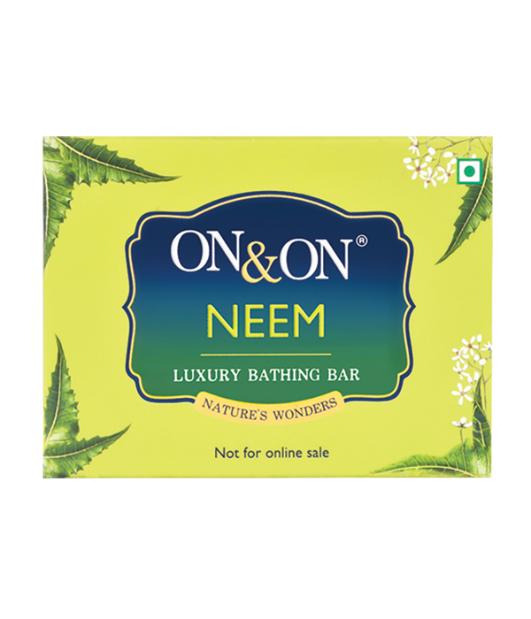
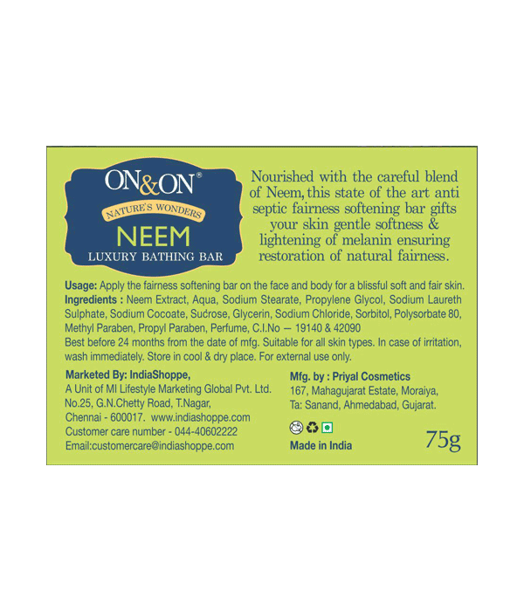
Product Description:
Ingredients: Propylene Glycol, Coconut Oil, Stearic Acid, Glycerin, Isopropyl Alcohol, Sodium Laureth Nourished with the careful blend of Neem, this state of the art anti-septic fairness softening bar gifts your skin gentle softness & lightening of skin ensuring restoration of natural fairness.
Directions for use: Wet skin and apply the bathing bar on the face and body for a blissful soft and fair skin.
Ether Sulphate, Sorbitol, Sodium Hydroxide, Sugar, Cocamidopropyl Betaine, Butylated HSydroxytoluene, DM Water, Perfume, Neem Extract, CI NO. 42090, CI No. 19140
storage: Store in a cool, dry place, away from direct sunlight. For external use only.
Manufactured by: Priyal Cosmetics 167, Mahagujarat Estate, Moraiya, Ta: Sanand, Ahmedabad, Gujarat. M.L. No: GC/1275
Marketed by: Mi Lifestyle Marketing Global Private Limited. No.25, G.N.Chetty Road, T. Nagar, Chennai - 600017, Tamil Nadu.
Shelf Life: Use before 24 months from the date of manufacture.

Additional Information: Enriched with neem extract for antiseptic properties. Contains glycerin and sugar crystals for additional skin nourishment. Suitable for all skin types, offering a luxurious bathing experience.
Used for: This luxury bathing bar is used for making skin smooth, adding softness, and providing antiseptic benefits, suitable for both body and face
Benefits: Makes skin smooth and adds softness. Helps in skin lightening, restoring natural fairness. Provides antiseptic properties, promoting healthy skin. Nourished with neem extract, glycerin, and sugar crystals for enhanced skin care.
Disclaimers: Suitable for all skin types. In case of irritation, wash immediately. For external use only.
ON&ON Papaya Luxury Bathing Bar (75g) MRP₹96.00
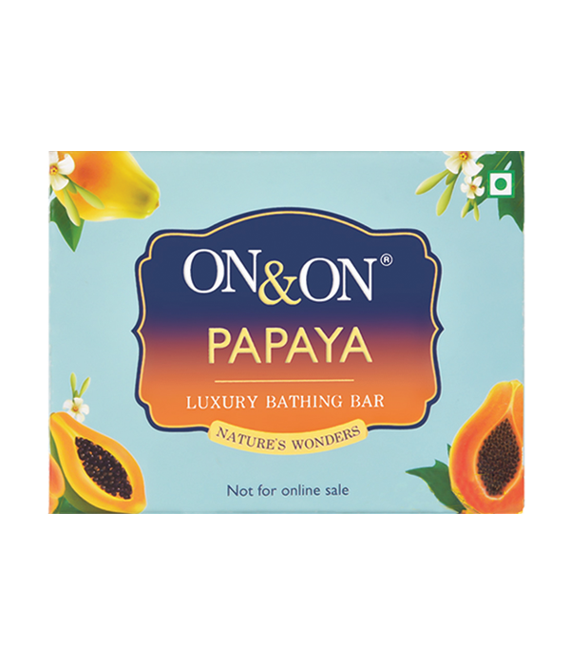
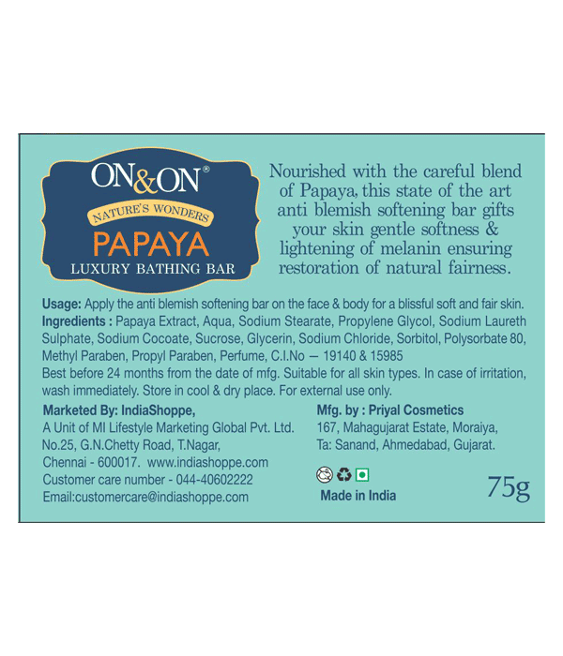

Product Description:
Nourished with the careful blend of Papaya, this state of the art anti-blemish softening bar gifts your skin gentle softness.
Net Content: 75g

Directions for use: Wet skin and apply the bathing bar on the face and body for a blissful soft and fair skin.

Ingredients: Propylene Glycol, Coconut Oil, Stearic Acid, Glycerin, Isopropyl Alcohol, Sodium Laureth Ether Sulphate, Sorbitol, Sodium Hydroxide, Sugar, Cocamidopropyl Betaine, Butylated Hydroxytoluene, DM Water, Perfume, Papaya Extract, CI NO.15985, CI No. 19140.

Storage: Store in a cool, dry place, away from direct sunlight. For external use only.

Marketed by: Priyal Cosmetics 167, Mahagujarat Estate, Moraiya, Ta: Sanand, Ahmedabad, Gujarat. M.L. No: GC/1275

Marketed by: Mi Lifestyle Marketing Global Private Limited. No.25, G.N.Chetty Road, T. Nagar, Chennai - 600017, Tamil Nadu.

Shelf Life: Use before 24 months from the date of manufacture.

Additional Information:

Enriched with papaya extract for anti-blemish properties. Contains glycerin and sugar crystals for additional skin nourishment. Suitable for all skin types, offering a luxurious bathing experience.

Used for: This luxury bathing bar is used for making skin smooth, adding softness, and reducing blemishes, suitable for both body and face.
Benefits: Makes skin smooth and adds softness. Helps in skin lightening, restoring natural fairness. Reduces blemishes and promotes an even skin tone. Nourished with papaya extract, glycerin, and sugar crystals for enhanced skin care.
Disclaimers: In case of irritation, wash immediately. For external use only.

Nourished with the careful blend of Papaya, this state of the art anti-blemish softening bar gifts your skin gentle softness.
Net Content: 75g

Directions for use: Wet skin and apply the bathing bar on the face and body for a blissful soft and fair skin.

Ingredients: Propylene Glycol, Coconut Oil, Stearic Acid, Glycerin, Isopropyl Alcohol, Sodium Laureth Ether Sulphate, Sorbitol, Sodium Hydroxide, Sugar, Cocamidopropyl Betaine, Butylated Hydroxytoluene, DM Water, Perfume, Papaya Extract, CI NO.15985, CI No. 19140.

Storage: Store in a cool, dry place, away from direct sunlight. For external use only.

Marketed by: Priyal Cosmetics 167, Mahagujarat Estate, Moraiya, Ta: Sanand, Ahmedabad, Gujarat. M.L. No: GC/1275

Marketed by: Mi Lifestyle Marketing Global Private Limited. No.25, G.N.Chetty Road, T. Nagar, Chennai - 600017, Tamil Nadu.

Shelf Life: Use before 24 months from the date of manufacture.

Additional Information:

Enriched with papaya extract for anti-blemish properties. Contains glycerin and sugar crystals for additional skin nourishment. Suitable for all skin types, offering a luxurious bathing experience.

Used for: This luxury bathing bar is used for making skin smooth, adding softness, and reducing blemishes, suitable for both body and face.
Benefits: Makes skin smooth and adds softness. Helps in skin lightening, restoring natural fairness. Reduces blemishes and promotes an even skin tone. Nourished with papaya extract, glycerin, and sugar crystals for enhanced skin care.
Disclaimers: In case of irritation, wash immediately. For external use only.

Neustar Anti Bacterial Triple Action Soap (100g) MRP
₹48.00

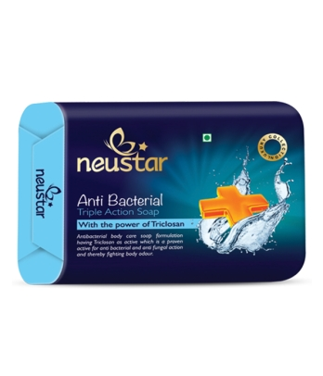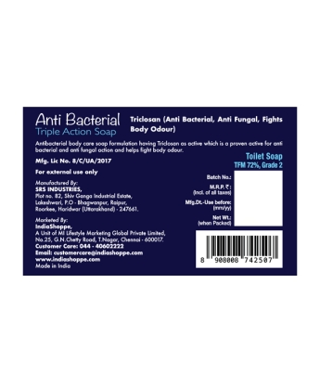

Product Description:
Anti-Bacterial Triple Action Soap comes with the power of Triclosan. Anti-bacterial body care soap formulation having Triclosan as active ingredient is a proven for anti-bacterial and anti-fungal action and thereby fighting body odour.
Net Content: 100g

Directions for use: Apply the soap on wet skin, lather, and rinse thoroughly.

Ingredients: Sodium Palmate, Sodium Palm Kernelate, Talc, Glycerin, Aqua, Fragrance, Sodium Chloride, Disodium EDTA, Triclosan, Titanium Di Oxide, Butylated Hydroxy Toluene, CI 12150, CI 12740.

Storage: Store in a cool and dry place, away from direct sunlight. Keep the soap dry between uses to extend its lifespan. For external use only.

Manufactured by: SRS INDUSTRIES, Plot no. 82, Shiv Ganga Industrial Estate, Lakeshwari, P.O - Bhagwanpur, Raipur, Roorkee, Haridwar (Uttarakhand) - 247661. Mfg. Lic No. 8/C/UA/2017
Marketed by: IndiaShoppe, A Unit of MI Lifestyle Marketing Global Private Limited, No.25, G.N.Chetty Road, T.Nagar, Chennai - 600017, Tamil Nadu

Shelf Life: Use before 36 months from the date of manufacture.

Additional Information: Neustar Anti-Bacterial Triple Action Soap is formulated with Triclosan, a proven active ingredient known for its antibacterial and antifungal properties. This soap helps fight body odour while providing effective body care, ensuring cleanliness and hygiene.
Used for: Daily cleansing, antibacterial protection, antifungal action, and fighting body odour.
Benefits: Triclosan, the key ingredient, provides antibacterial and antifungal action, effectively combating body odour and ensuring the skin remains clean and protected from harmful microorganisms.
Disclaimers: For external use only.

